http://blog.csdn.net/zhuquan945/article/details/52818786

devin@ubuntu:/usr/bin$ qmake

qmake: could not exec '/usr/lib/x86_64-linux-gnu/qt4/bin/qmake': No such file or directory

解决办法：

将/usr/lib/x86_64-linux-gnu/qt-default/qtchoooster的default.conf文件中的第一行改为：/home/zhuquan/Qt5.7.0/5.7/gcc_64/bin

但default.conf文件是只读的，所以要改下权限：

zhuquan@zhuquan-HP-Z230-Tower-Workstation:~$ sudo chmod 777 /usr/lib/x86_64-linux-gnu/qt-default/qtchooser/default.conf

然后在default.conf文件中写入

/home/zhuquan/Qt5.7.0/5.7/gcc_64/bin（注：此为qmake所在的路径）

/usr/lib/x86_64-linux-gnu

改好，保存。

再在终端输入：

zhuquan@zhuquan-HP-Z230-Tower-Workstation:~$ qmake -v

显示结果为：

QMake version 3.0

Using Qt version 5.7.0 in /home/zhuquan/Qt5.7.0/5.7/gcc_64/lib

找到default.conf文件

devin@ubuntu:/usr/lib/x86_64-linux-gnu/qt-default/qtchooser$ ls

default.conf

devin@ubuntu:/usr/lib/x86_64-linux-gnu/qt-default/qtchooser$ pwd

/usr/lib/x86_64-linux-gnu/qt-default/qtchooser

devin@ubuntu:/usr/lib/x86_64-linux-gnu/qt-default/qtchooser$

修改为：

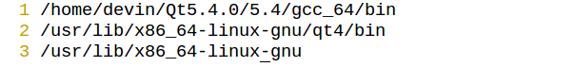

1. 是本地安装的qt版本路径下的含有qmake的路径，保存之后，再在Qt的工程路径中使用qmake，make

**QT官网的源代码下载**

QT官网下载源代码，或单个模块的源代码方法

<https://www.qt.io/download-open-source/>

You can get split source packages from here. Or visit the repository at code.qt.io.

<http://download.qt.io/official_releases/qt/5.8/5.8.0/submodules/> 单个模块的源代码

Source packages & Other releases

The source code is available:

For Windows users as a single zip file (565 MB) (Info)

For Linux/macOS users as a tar.gz file (465 MB) (Info)

You can get split source packages from here. Or visit the repository at code.qt.io.

Qt 5.7 and all older versions of Qt are available in the archive.

可以下载整个的源代码；例如：qt-everywhere-opensource-src-5.8.0.tar.gz

下载完成之后，解压一下文件

tar –xvzf qt-everywhere-opensource-src-5.8.0.tar.gz 解压完成之后进入该目录中

ls 查看一下

**devin@ubuntu:~/Downloads/qt-everywhere-opensource-src-5.8.0$ ls**

**coin LICENSE.GPLv3 qtcanvas3d qtimageformats qtquickcontrols2 qttools qtwinextras**

**configure LICENSE.LGPLv21 qtcharts qtlocation qtscript qttranslations qtx11extras**

**configure.bat LICENSE.LGPLv3 qtconnectivity qtmacextras qtscxml qtvirtualkeyboard qtxmlpatterns**

**configure.json LICENSE.PREVIEW.COMMERCIAL qtdatavis3d qtmultimedia qtsensors qtwayland README**

**gnuwin32 qt3d qtdeclarative qtnetworkauth qtserialbus qtwebchannel**

**LGPL_EXCEPTION.txt qtactiveqt qtdoc qt.pro qtserialport qtwebengine**

**LICENSE.FDL qtandroidextras qtgamepad qtpurchasing qtspeech qtwebsockets**

**LICENSE.GPLv2 qtbase qtgraphicaleffects qtquickcontrols qtsvg qtwebview**

**devin@ubuntu:~/Downloads/qt-everywhere-opensource-src-5.8.0$ ./configure**

**+ cd qtbase**

**+ /home/devin/Downloads/qt-everywhere-opensource-src-5.8.0/qtbase/configure -top-level**

**Which edition of Qt do you want to use ?**

**Type 'c' if you want to use the Commercial Edition.**

**Type 'o' if you want to use the Open Source Edition.**

**o**

**This is the Qt Open Source Edition.**

**You are licensed to use this software under the terms of**

**the GNU Lesser General Public License (LGPL) version 3.**

**You are also licensed to use this software under the terms of**

**the GNU General Public License (GPL) version 2.**

**Type 'L' to view the GNU Lesser General Public License version 3.**

**Type 'G' to view the GNU General Public License version 2.**

**Type 'yes' to accept this license offer.**

**Type 'no' to decline this license offer.**

**Do you accept the terms of either license?**

**You are licensed to use this software under the terms of**

**the GNU Lesser General Public License (LGPL) version 3.**

**You are also licensed to use this software under the terms of**

**the GNU General Public License (GPL) version 2.**

**Type 'L' to view the GNU Lesser General Public License version 3.**

**Type 'G' to view the GNU General Public License version 2.**

**Type 'yes' to accept this license offer.**

**Type 'no' to decline this license offer.**

**Do you accept the terms of either license? yes**

**Creating qmake...**

**........................................................................................Done.**

**Info: creating stash file /home/devin/Downloads/qt-everywhere-opensource-src-5.8.0/.qmake.stash**

**Info: creating super cache file /home/devin/Downloads/qt-everywhere-opensource-src-5.8.0/.qmake.super**

创建qmake

………………………………………………………………

Note: Dropped compiler flags '-pthread' when detecting library 'glib'.

Note: No wayland-egl support detected. Cross-toolkit compatibility disabled.

Platform notes:

- Also available for Linux: linux-clang linux-kcc linux-icc linux-cxx

Qt is now configured for building. Just run 'make'.

Once everything is built, you must run 'make install'.

Qt will be installed into /usr/local/Qt-5.8.0

Prior to reconfiguration, make sure you remove any leftovers from

the previous build.

<http://www.cnblogs.com/tangkaixuan/p/6504097.html>

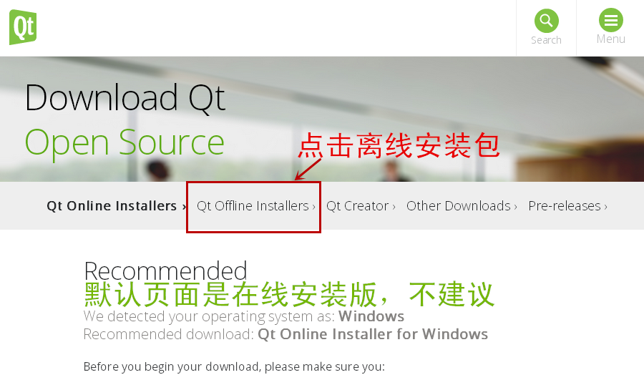

Qt 网站默认是使用在线安装版，这个压根不好使。不要用在线安装的，我们点击上面的 "Qt Offline Installers" ，可以看到展开之后的各种离线安装包（本节教程页面更新时为 Qt 5.5.0 版本，读者可以安装这个最新版本，不影响后面教程的学习）：

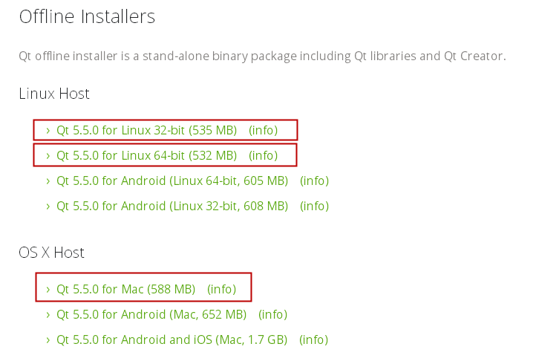

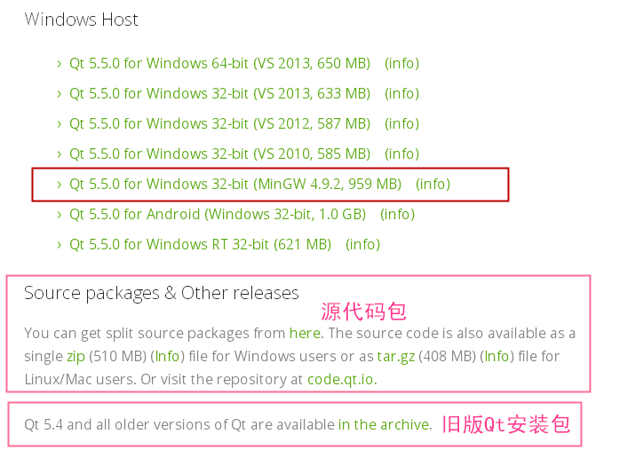

三个操作系统常用的 Qt 开发环境安装包在图上标出来了，Linux 系统有 32 位和 64 位两个常用版本；Mac OS X 系统有一个常用的版本；Windows 系统常用的是 MinGW 版本。

对于 Visual Studio 版本的 Qt 库，如果是 Qt 开发老手可以使用，对于新手而言不建议使用，因为配置麻烦，Visual Studio 开发 Qt 程序的效率很低，本教程选择的是最适合新手使用的 MinGW 版本开发环境。

本节关于下载的内容介绍到这里，后面几节示范 Qt 开发环境在 Windows 和 Linux 系统里的安装过程，因为作者没有苹果系统，就不示范在苹果系统里的安装了，况且苹果系统使用的人也少，所以就忽略苹果系统了。

解决qt 下使用multiMedia 的 gstreamer播放视频问题的方案：更新所有的Ubuntu下和gstreamer相关的库